**BlueJay Practice Schedule**

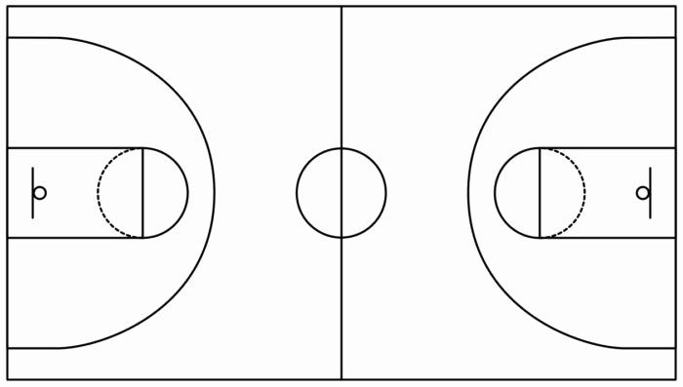

* **5 Minutes – 2 Line Lay-Ups**
* **12 Minutes – Decision-Making**
  + No Defense on ball to start, read help defender (see chest, make pass – see shoulder, keep going)
* **8 Minutes – Shell**
  + Jump to Pass, Everyone Moves on Ball
  + Offense 2 Dribble Max, Defensive Player in Gap Get Offensive Player Stopped (Offensive Player Dribble at Basket)
  + Add Cutting & Allow Shooting
* **8 Minutes – Partner Shooting (1 Dribble Pull-Ups)**
* **7 Minutes – Offensive Spacing / Motion – Small Side Games**
* **5 Minutes – Out of Bounds Plays**
* **15 Minutes – Scrimmage**