**BlueJay Practice Schedule**

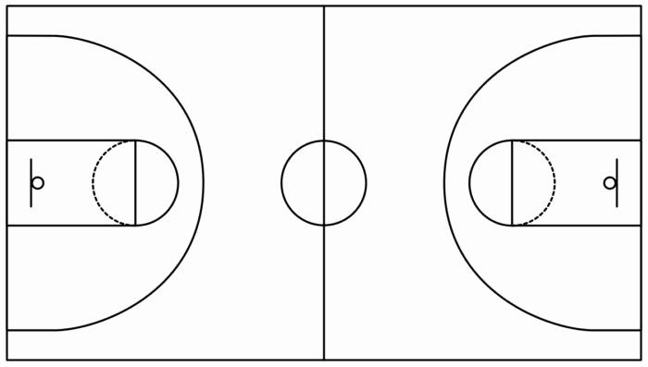

* **5 Minutes –**
* **12 Minutes –**
* **8 Minutes –**
* **8 Minutes –**
* **7 Minutes –**
* **5 Minutes –**
* **15 Minutes –**